Title and Focus of Activity: Motor System Learning Activity and Motor System Quiz
Linking foundational and clinical sciences

Contributor(s): Michael McKeough, PT, EdD; mmckeough@csus.edu California State University Sacramento, Department of Physical Therapy

Course Information: Neuroscience, adjunctive learning activity within a neuroscience course

Learning Activity Description: This patient case-based learning activity is intended as adjunct to lecture on the structure and function of the motor system and clinical presentation of patients with lesions of the motor system. Its advantage is that it parallels the clinical reasoning involved in examining the effects of lesions of the motor system, i.e., it presents simultaneously and in parallel both the behavioral level (clinical presentation) and anatomical level information about lesions at various levels of the motor system. It contains 3 interactive lesion lessons and 2 patient cases with feedback. It utilizes computer animation to show the injury occurring (scalpel), the neuroanatomy affected, and the clinical impairment’s presented by the patient.
Below are example screen shots from relevant content. See PowerPoint Show files entitled Motor Control System and Motor System Quiz.
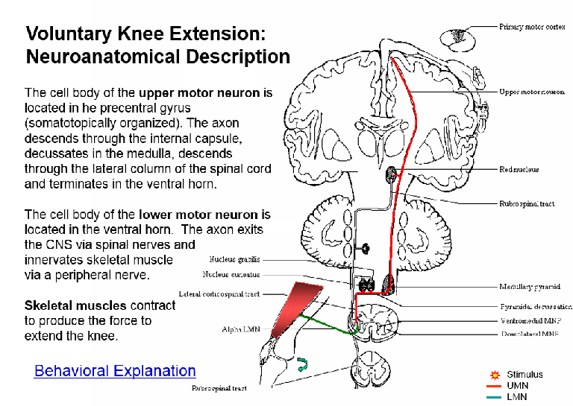
Screen shot showing Voluntary Knee Extension: Behavioral Description. Example of neuroanatomical and
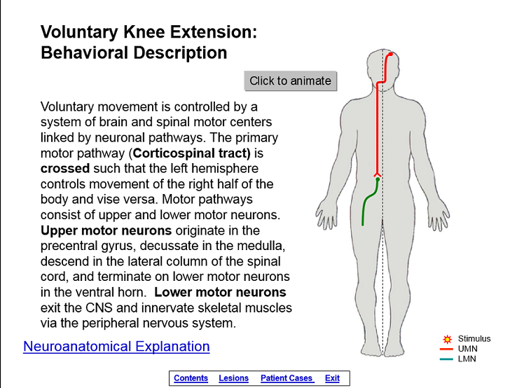
“Click to animate” produces upper motor behavioral explanations. Slide selection
And lower motor neurons. Click on Neuroanatom- automatically initiates animation showing
ical Explanation links to next screen. Pathway of UMN, LMN, and peripheral
nerve activating quadriceps muscle
producing knee extension.
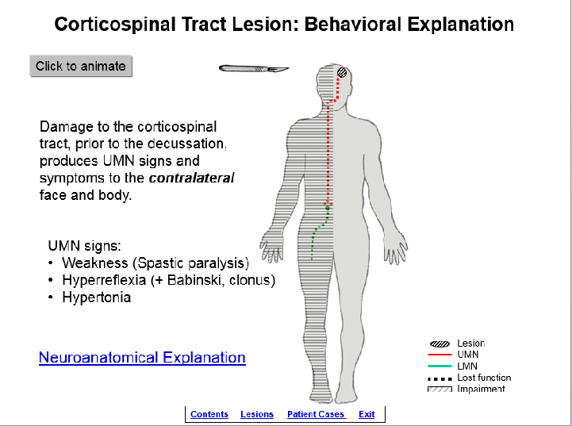
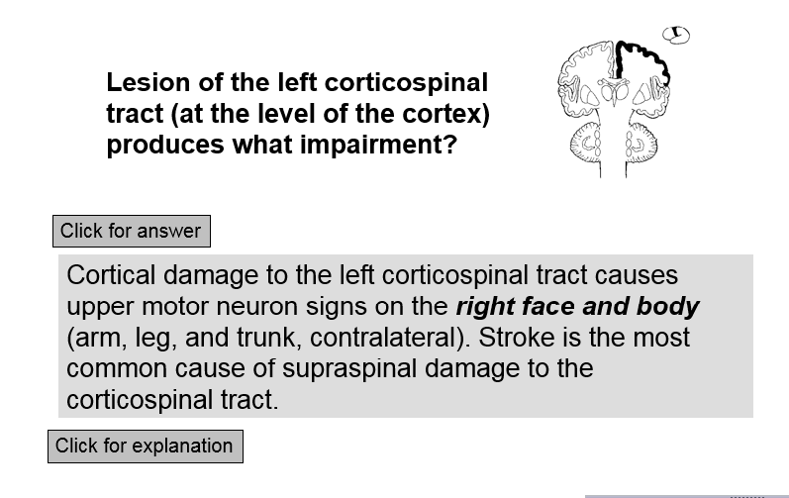
Screen shot of patient case asking what Screen shot of Behavioral Explanation.
Impairment is expected given the lesion. “Click to animate” produces scalpel
Clicking for explanation reveals the neuro- damaging left cortex resulting in effects of
anatomical and behavioral substrate. UMN & LMN lesions producing contralateral
hemiplegia at the behavioral level. Clicking o on Neuroanatomical Explanation leads to next o slide.

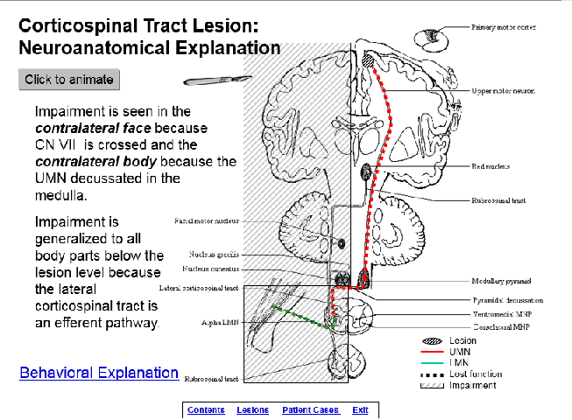

Screen shot of Neuroanat. Explanation.
“Click to animate” produces scalpel damaging
left cortex resulting in effects of UMN & LMN
lesions producing contralateral hemiplegia
at the anatomical level.
Time for student to complete the activity: 1. preparation for activity outside of/before class: 1-3 hours 2. class time completion of the activity: NA

Readings/other preparatory materials: Knowledge of the anatomy, physiology, pathophysiology, and clinical presentation of damage to the motor system.

Learning Objectives: 1. describe, in detail, the structure and function of the corticospinal tract. 2. given a lesion, identify the signs and symptoms that would be expected. 3. given a patient case (examination results and chief complaint), identify the location of the lesion causing the signs and symptoms. 4. correlate neurology information between the behavioral and neuroanatomical levels.

Methods of evaluation of student learning: Traditional written exams that cover this and similar material.
The effects of using this learning module have not been examined. In previous research, a similar learning module, as a stand-alone activity not coupled with lecture on the same material, demonstrated the ability to significantly increase student knowledge about the anatomy and clinical effects of lesions of the spinal cord and student’s clinical self-efficacy.¹
¹McKeough, DM; Drumheller N, Gardner E, Barakatt, ET. THE EFFECTS OF A COMPUTER-BASED LEARNING MODULE ON STUDENTS’ KNOWLEDGE OF SPINAL CORD LESIONS, Annual Conference of the California Physical Therapy Association, Poster Presentation, 2013.

