Title and Focus of Activity: Clinical Application of the LST Linking foundational and clinical sciences

Contributor(s): Michael McKeough, PT, EdD; mmckeough@csus.edu California State University Sacramento, Department of Physical Therapy

Course Information: Neuroscience, adjunctive learning activity within a neuroscience course

Learning Activity Description: This patient case-based learning activity is intended as adjunct to lecture on the structure and function of the lateral spinothalamic system (LST) and clinical presentation of patients with lesions of that system. Its advantage is that it parallels the clinical reasoning involved in examining the effects of lesions of the LST, i.e., it presents simultaneously and in parallel both the behavioral level (clinical presentation) and anatomical level information about lesions at various levels of the lateral spinothalamic system. It contains 3 interactive lesion lessons and 4 patient cases with feedback. It utilizes computer animation to show the injury occurring (scalpel), the neuroanatomy affected, and the clinical impairments presented by the patient.
Below are example screen shots from relevant content. See PowerPoint file: The Spinothalamic System
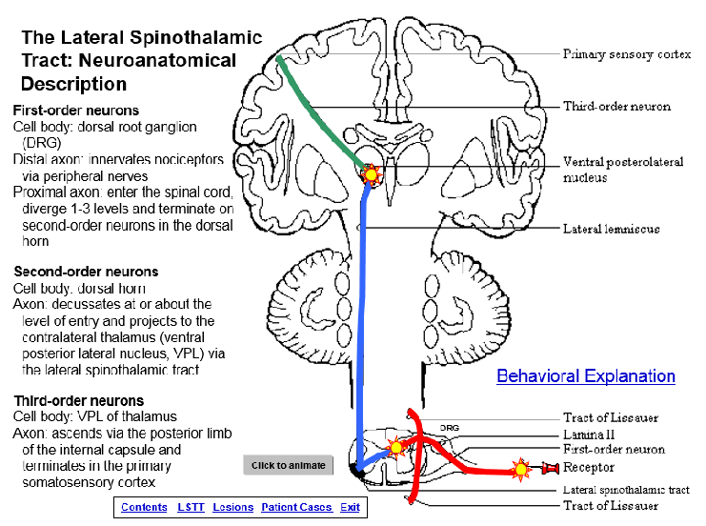
Screen shot showing behavioral description of Lateral Spinothalamic Tract. Shows adequate Slide showing neuroanatomical organization of
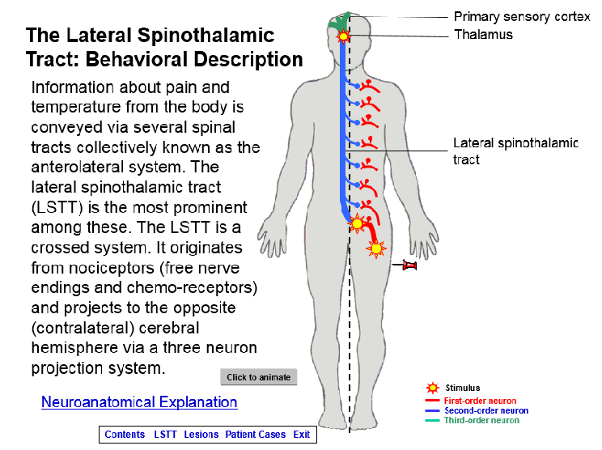
Stimulus, first-, second-, and third-order neurons. lateral spinothalamic tract including,
Click on Neuroanatomical Explanation reveals stimulus, first- , second-, and third-order
next slide. neurons. “Click to animate” portrays information
traveling from stimulus throughout the
tract.
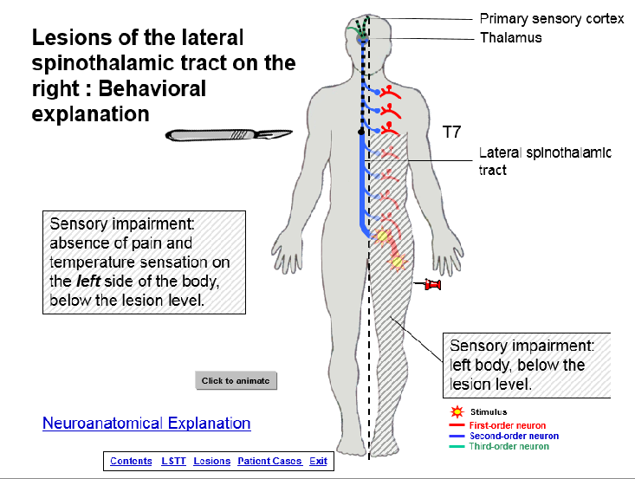
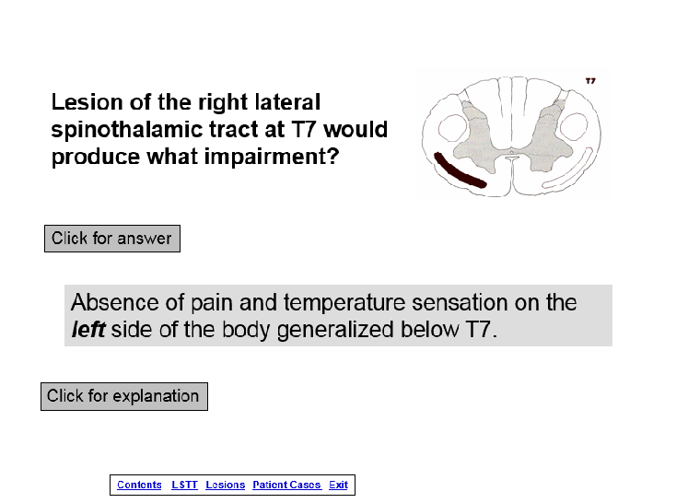

Screen shot showing diagram of lesion and Example of behavioral explanation.
question about clinical impairment. Click for Click to animate produces, 1) scalpel causing answer reveals the answer. Click for the lesion, 2) pin showing clinical test,
explanation reveals behavioral explanation. 3) first-order neuron interrupted by lesion, (next screen). 4) shaded area indicating area of damage and clinical presentation of impairment.

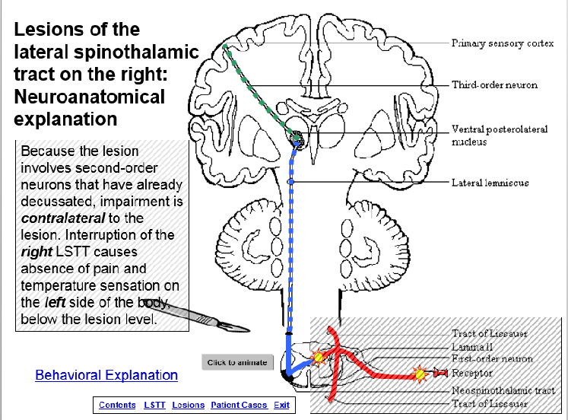

Example of neuroanatomical explanation.
Click to animate produces, 1) scalpel causing
the lesion, 2) pin showing clinical test,
3) first-order neuron interrupted by lesion,
4) text box explaining clinical findings.

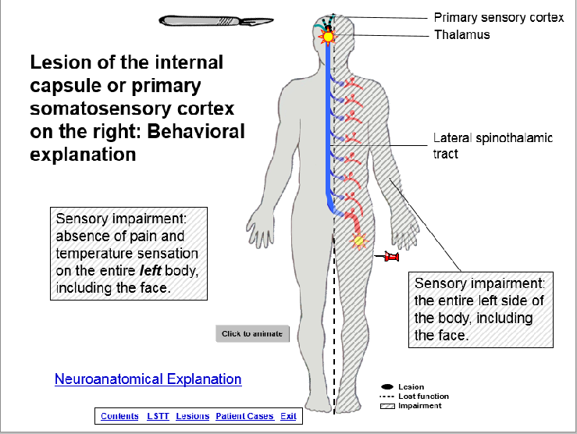
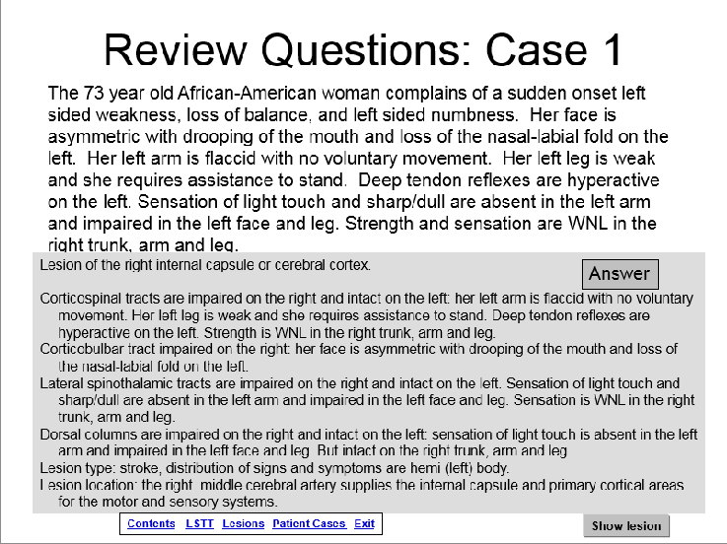
Screen shot of patient case asking damage Screen shot of Behavioral Explanation.
to what structure is causing the patient’s Click to animate produces scalpel damaging
problems. Click for answer reveals answer. internal capsule. Animation shows stimulus
Clicking on Show Lesion brings next slide. and third-order neuron failing at lesion site.
Text boxes show sensory impairment. Clicking on Neuroanatomical Explanation
brings next slide.

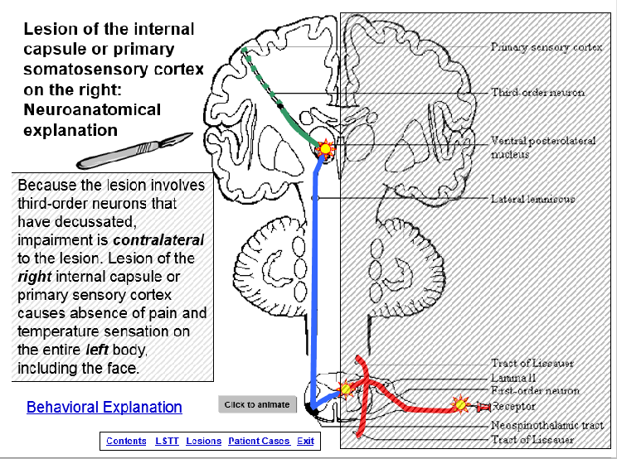

Screen shot of Neuroanat. Explanation.
Click to animate produces scalpel damaging
Internal capsule, transmission fails at lesion.
Text box explains clinical findings at the
anatomical level.
Time for student to complete the activity: 1. preparation for activity outside of/before class: 1-3 hours 2. class time completion of the activity: NA

Readings/other preparatory materials: Knowledge of the anatomy, physiology, pathophysiology, and clinical presentation of damage to the lateral spinothalamic system.

Learning Objectives: 1. describe, in detail, the structure and function of the lateral spinothalamic system. 2. given a lesion, identify the signs and symptoms that would be expected. 3. given a patient case (examination results and chief complaint), identify the location of the lesion causing the signs and symptoms. 4. correlate neurology information between the behavioral and neuroanatomical levels.

Methods of evaluation of student learning: Traditional written exams that cover this and similar material.
The effects of using this learning module have not been examined. In previous research, a similar learning module, as a stand-alone activity not coupled with lecture on the same material, demonstrated the ability to significantly increase student knowledge about the anatomy and clinical effects of lesions of the spinal cord and student’s clinical self-efficacy.¹
¹McKeough, DM; Drumheller N, Gardner E, Barakatt, ET. THE EFFECTS OF A COMPUTER-BASED LEARNING MODULE ON STUDENTS’ KNOWLEDGE OF SPINAL CORD LESIONS, Annual Conference of the California Physical Therapy Association, Poster Presentation, 2013.

