Title and Focus of Activity: Visual Pathways Learning Activity Linking foundational and clinical sciences

Contributor(s): Michael McKeough, PT, EdD; mmckeough@csus.edu California State University Sacramento, Department of Physical Therapy

Course Information: Neuroscience, adjunctive learning activity within a neuroscience course

Learning Activity Description: This patient case-based learning activity is intended as adjunct to lecture on the structure and function of the central visual pathway and clinical presentation of patients with lesions of that pathway. Its advantage is that it parallels the clinical reasoning involved in examining the effects of lesions of the central visual pathway, i.e., it presents simultaneously and in parallel both the behavioral level (clinical presentation) and anatomical level information about lesions at various locations in the pathway. It contains an overview of normal anatomy and physiology, 4 interactive lesion lessons and 2 patient cases with feedback. It utilizes computer animation to show the injury occurring (scalpel), the neuroanatomy affected, and the clinical impairment’s presented by the patient.

Below are example screen shots from relevant content. See PowerPoint file entitled Central Visual Pathways.

Screen shot showing structure & function of Central Visual Pathway. Shows visual target,
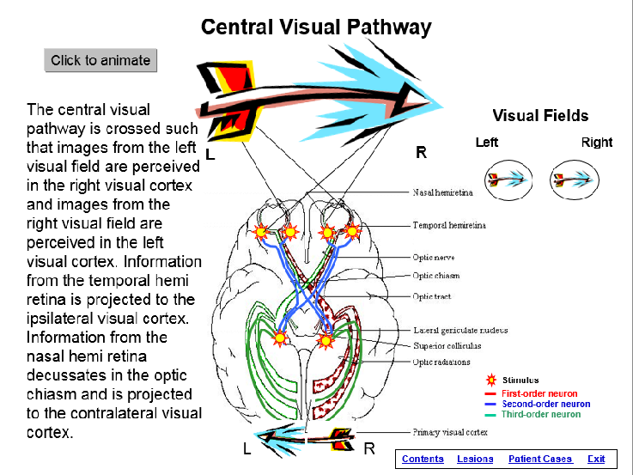
second-, third-order neurons and cortical projection.
“Click to animate” shows projections along central pathway and visual fields.

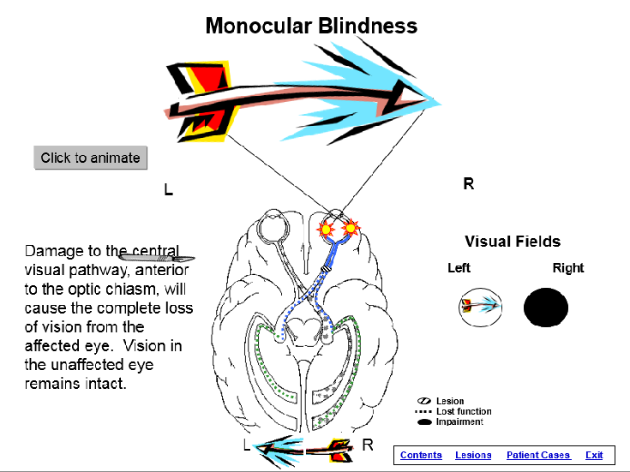
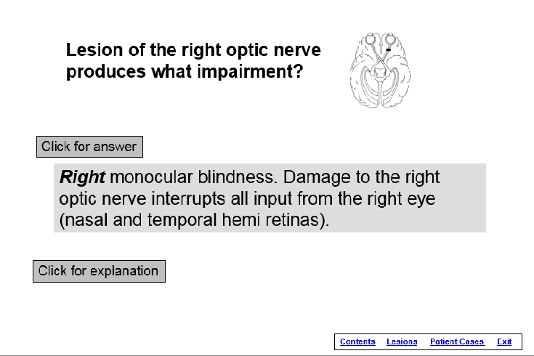

Screen shot showing diagram of lesion and Example of neuroanatomical explanation of
question about clinical impairment. “Click for Monoccular Blindness. “Click to animate”
answer” reveals the answer. “Click for produces scalpel causing lesion of optic
explanation” (next screen). nerve and visual field deficit.

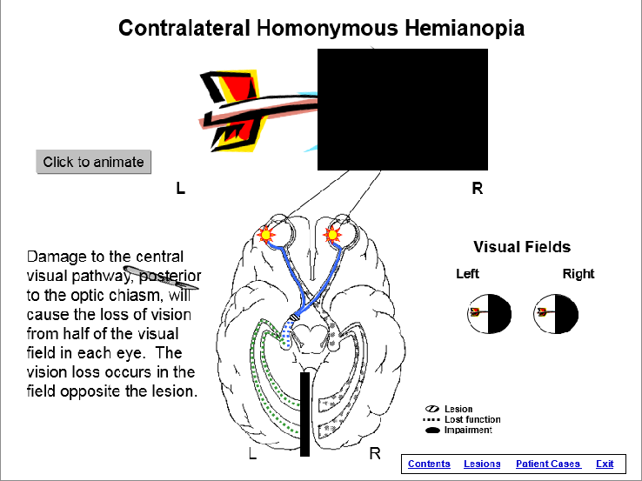
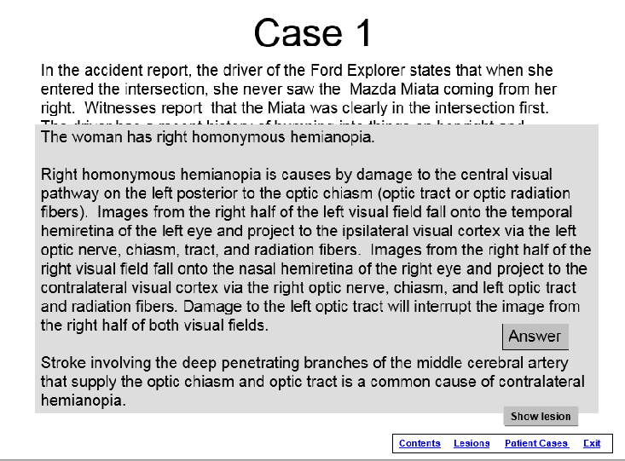
Screen shot of patient case asking damage Screen shot of hemianopia.
to what structure is causing the patient’s “Click to animate” produces scalpel damaging
problems. “Click for answer” reveals answer. Optic tract. Animation shows anatomical
Clicking on Show Lesion brings next slide. lesion and visual field deficit.

Time for student to complete the activity: 1. preparation for activity outside of/before class: 1-3 hours 2. class time completion of the activity: NA

Readings/other preparatory materials: Knowledge of the anatomy, physiology, pathophysiology, and clinical presentation of damage to the central visual pathway

Learning Objectives: 1. describe, in detail, the structure and function of the central visual pathway 2. given a patient case (examination results and chief complaint), identify the lesion causing the symptoms. 3. given a lesion, identify the signs and symptoms that would be expected on examination. 4. correlate neurology information between the level of visual image and central visual pathway.

Methods of evaluation of student learning: Traditional written exams that cover this and similar material.
The effects of using this learning module have not been examined. In previous research, a similar learning module, as a stand-alone activity not coupled with lecture on the same material, demonstrated the ability to significantly increase student knowledge about the anatomy and clinical effects of lesions of the spinal cord and student’s clinical self-efficacy.¹
¹McKeough, DM; Drumheller N, Gardner E, Barakatt, ET. THE EFFECTS OF A COMPUTER-BASED LEARNING MODULE ON STUDENTS’ KNOWLEDGE OF SPINAL CORD LESIONS, Annual Conference of the California Physical Therapy Association, Poster Presentation, 2013.

